**MODULE 2 - SCM WITH GIT**

**Problem Statement**

Three Developers are working in Aperture Technology co. Their company wants a better Source Code Management System because the earlier tool had the tendency to save redundant code. Multiple Developers working simultaneously on the same block of code also caused problems. You are Mike, and your manager has given you the task of moving the company’s code base to

git and GitHub.

* Create a local git repository and move the entire code base to it

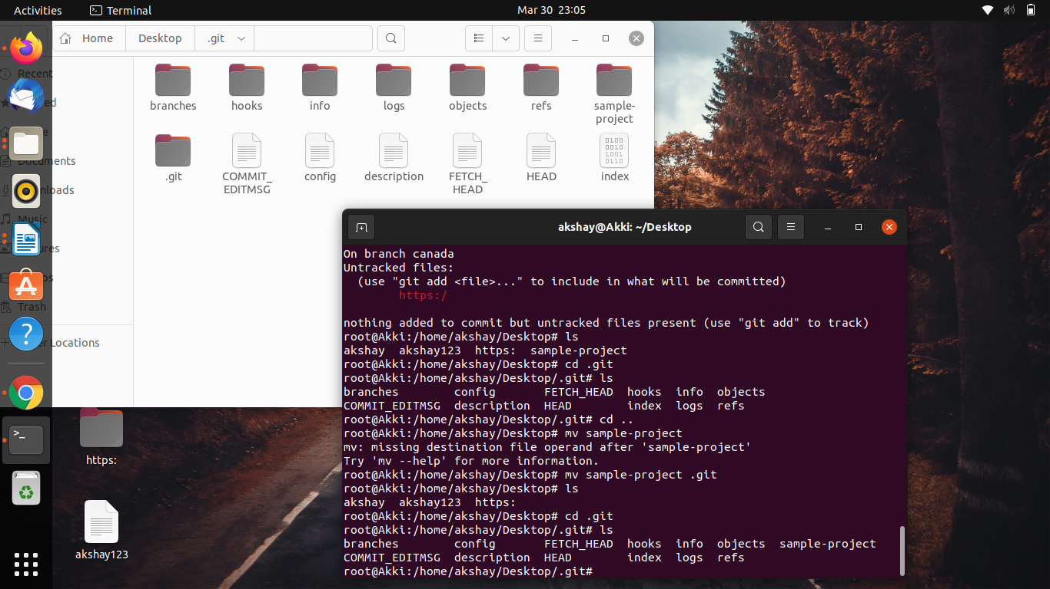

* Create a new branch for a new feature you want to add to the application

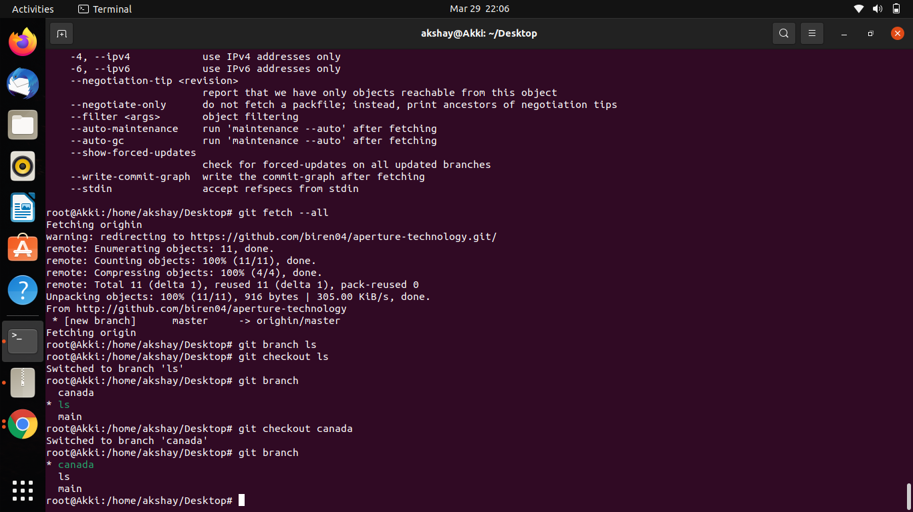

* Merge back the created branch with the master branch

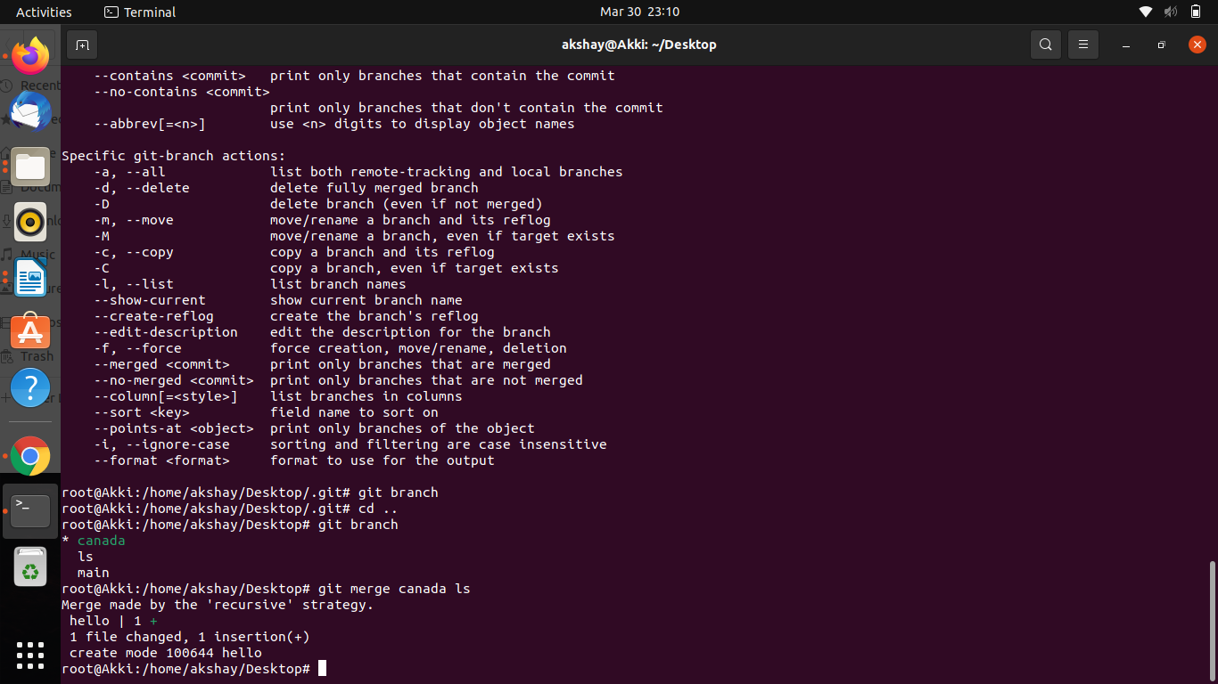

* Create a remote repository
* 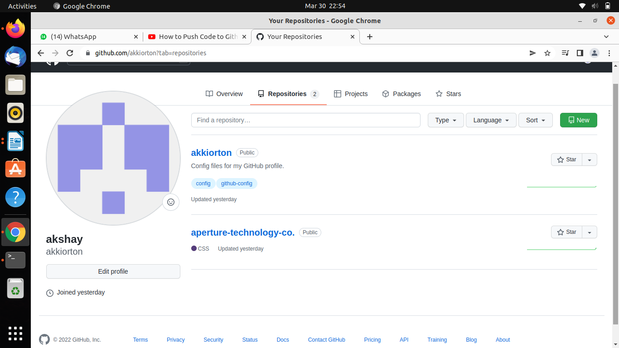
* 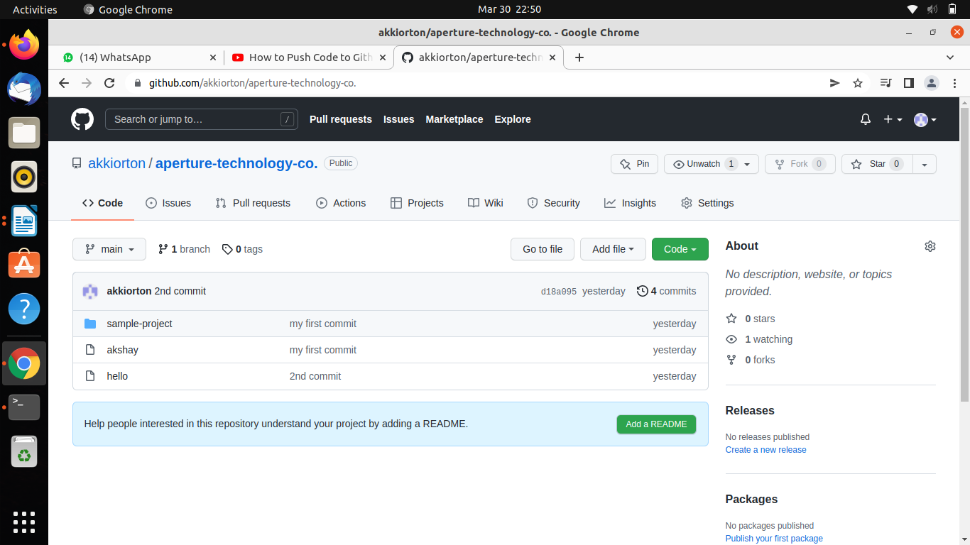Push the local repository to company’s remote repository